|  |  |  |  |  |  |  |  |  |  |  |  |
| --- | --- | --- | --- | --- | --- | --- | --- | --- | --- | --- | --- |
|  | | **Finolex Academy of Management and Technology, Ratnagiri** | | | | | | | | | |
| **Department of Information Technology** | | | | | | | | | |
| Subject name: Big Data Analytics | | | | | | | | Subject Code: ITC801 | | | |
| Class | | BE IT | | Semester – VIII (CBGS) | | | | Academic year: 2019-20 | | | |
| Name of Student | | **Kazi Jawwad A Rahim** | | | | | **QUIZ Score :** | | | | |
| Roll No | | **28** | | | Assignment/Experiment No. | | | | | 08 | |
| Title:  **Implementation of HITS Algorithm** | | | | | | | | | | | |
|  | | | | | | | | | | | |
| **1. Course objectives applicable:**  **COB4**.Study Page Rank in Link Analysis and concepts of Handling larger datasets | | | | | | | | | | | |
| **2. Course outcomes applicable:**  **CO4**-Implement use of combiners to consolidate results and ability to handle larger datasets | | | | | | | | | | | |
| **3. Learning Objectives:**   1. To understand concept of HITS 2. To understand Hubs and Authorities 3. To program HITS Score computation in C/C++ 4. To prove that HITS Converges after certain iterations | | | | | | | | | | | |
| **4. Practical applications of the assignment/experiment: HITS Algorithm is used by Ask.com Search engine for indexing of webpages and giving results for search queries** | | | | | | | | | | | |
| **5. Prerequisites**:   1. Understanding of Internet Technologies | | | | | | | | | | | |
| **6. Hardware Requirements**:   1. PC with 4GB RAM, 500GB HDD,   **7. Software Requirements:**  1. Access to C/C++ compiler  2. Internet access if online compiler is used | | | | | | | | | | | |
|  | | | | | | | | | | | |
| **8. Quiz Questions (if any): (Online Exam will be taken separately batchwise, attach the certificate/ Marks obtained)**   1. What is a HITS? 2. What is HUB? 3. What is a Authority Page? 4. What is SCC? | | | | | | | | | | | |
|  | | | | | | | | | | | |
| **9. Experiment/Assignment Evaluation:** | | | | | | | | | | | |
| **Sr. No.** | **Parameters** | | | | | | | | **Marks obtained** | | **Out of** |
| **1** | Technical Understanding (Assessment may be done based on Q & A **or** any other relevant method.) Teacher should mention the other method used - | | | | | | | |  | | 6 |
| **2** | Neatness/presentation | | | | | | | |  | | 2 |
| **3** | Punctuality | | | | | | | |  | | 2 |
| **Date of performance (DOP)** | | |  | | | **Total marks obtained** | | |  | | **10** |
| **Date of checking (DOC)** | | |  | | | **Signature of teacher** | | | | | |

**12. Installation Steps / Performance Steps –**

**PageRank Program with Teleportation:**

import java.util.*;

import java.io.*;

import java.lang.*;

import static java.lang.Math.*;

public class hits341 {

int iter;

int initval;

String filename;

int n; // number of vertices in the graph

int m; // number of edges in the graph

int[][] L; // adjacency matrix

double[] h0;

double[] a0;

final double errorrate = 0.00001;

hits341() {} //default constructor

hits341(int iter, int initval, String filename) // 3 argument constructor to initialize class variables with provided command line arguments

{

this.iter = iter;

this.initval = initval;

this.filename = filename;

try {

Scanner scanner = new Scanner(new File(filename));

n = scanner.nextInt();

m = scanner.nextInt();

//System.out.println("n = " + n + " m = " + m);

//Adjacency matrix representation of graph

L = new int[n][n];

for(int i = 0; i < n; i++)

for(int j = 0; j < n; j++)

L[i][j] = 0;

while(scanner.hasNextInt())

{

L[scanner.nextInt()][scanner.nextInt()] = 1;

//System.out.println(scanner.nextInt());

}

h0 = new double[n];

a0 = new double[n];

switch(initval) {

case 0:

for(int i = 0; i < n; i++) {

h0[i] = 0;

a0[i] = 0;

}

break;

case 1:

for(int i = 0; i < n; i++) {

h0[i] = 1;

a0[i] = 1;

}

break;

case -1:

for(int i =0; i < n; i++) {

h0[i] = 1.0/n;

a0[i] = 1.0/n;

}

break;

case -2:

for(int i =0; i < n; i++) {

h0[i] = 1.0/Math.sqrt(n);

a0[i] = 1.0/Math.sqrt(n);

}

break;

}

}

catch(FileNotFoundException fnfe){}

}

public static void main(String[] args)

{

if(args.length != 3) {

System.out.println("Usage: hits3416 iterations initialvalue filename");

return;

}

//command line arguments

int iterations = Integer.parseInt(args[0]);

int initialvalue = Integer.parseInt(args[1]);

String filename = args[2];

if( !(initialvalue >= -2 && initialvalue <= 1) ) {

System.out.println("Enter -2, -1, 0 or 1 for initialvalue");

return;

}

hits3416 ht = new hits3416(iterations, initialvalue, filename);

ht.hitsAlgo3416();

}

boolean isConverged(double[] p, double[] q)

{

for(int i = 0 ; i < n; i++) {

if ( abs(p[i] - q[i]) > errorrate )

return false;

}

return true;

}

public void hitsAlgo3416()

{

double[] h = new double[n];

double[] a = new double[n];

double a_scale_factor = 0.0;

double a_sum_square = 0.0;

double h_scale_factor = 0.0;

double h_sum_square = 0.0;

double[] aprev = new double[n]; //last iterations values of a, used for convergence

double[] hprev = new double[n]; //last iterations values of h, used for convergence

//If the graph has N greater than 10, then the values for iterations, initialvalue revert to 0 and -1 respectively

if(n > 10) {

iter = 0;

for(int i =0; i < n; i++) {

h[i] = 1.0/n;

a[i] = 1.0/n;

hprev[i] = h[i];

aprev[i] = a[i];

}

int i = 0;

do {

for(int r = 0; r < n; r++) {

aprev[r] = a[r];

hprev[r] = h[r];

}

//A step starts

for(int p = 0; p < n; p++) {

a[p] = 0.0;

}

for(int j = 0; j < n; j++) {

for(int k = 0; k < n; k++) {

if(L[k][j] == 1) {

a[j] += h[k];

}

}

}//A step ends

//H step starts

for(int p = 0; p < n; p++) {

h[p] = 0.0;

}

for(int j = 0; j < n; j++) {

for(int k = 0; k < n; k++) {

if(L[j][k] == 1) {

h[j] += a[k];

}

}

}//H step ends

//Scaling A starts

a_scale_factor = 0.0;

a_sum_square = 0.0;

for(int l = 0; l < n; l++) {

a_sum_square += a[l]*a[l];

}

a_scale_factor = Math.sqrt(a_sum_square);

for(int l = 0; l < n; l++) {

a[l] = a[l]/a_scale_factor;

}//Scaling A ends

//Scaling H starts

h_scale_factor = 0.0;

h_sum_square = 0.0;

for(int l = 0; l < n; l++) {

h_sum_square += h[l]*h[l];

}

h_scale_factor = Math.sqrt(h_sum_square);

for(int l = 0; l < n; l++) {

h[l] = h[l]/h_scale_factor;

}// Scaling H ends

i++; // incr the interation counter

} while( false == isConverged(a, aprev) || false == isConverged(h, hprev));

System.out.println("Iter: " + i);

for(int l = 0; l < n; l++) {

System.out.printf(" A/H[%d]=%.6f/%.6f\n",l,Math.round(a[l]*1000000.0)/1000000.0,Math.round(h[l]*1000000.0)/1000000.0);

}

return;

}

//Initialization

for(int i = 0; i < n; i++)

{

h[i] = h0[i];

a[i] = a0[i];

hprev[i] = h[i];

aprev[i] = a[i];

}

//Base Case

System.out.print("Base: 0 :");

for(int i = 0; i < n; i++) {

System.out.printf(" A/H[%d]=%.4f/%.4f",i,Math.round(a0[i]*1000000.0)/1000000.0,Math.round(h0[i]*1000000.0)/1000000.0);

//System.out.println("a0[" + i + "]= " + a0[i]);

}

if (iter != 0) {

for(int i = 0; i < iter; i++) { //iteration starts

//A step starts

for(int p = 0; p < n; p++) {

a[p] = 0.0;

}

for(int j = 0; j < n; j++) {

for(int k = 0; k < n; k++) {

if(L[k][j] == 1) {

a[j] += h[k];

}

}

}//A step ends

//H step starts

for(int p = 0; p < n; p++) {

h[p] = 0.0;

}

for(int j = 0; j < n; j++) {

for(int k = 0; k < n; k++) {

if(L[j][k] == 1) {

h[j] += a[k];

}

}

}//H step ends

//Scaling A starts

a_scale_factor = 0.0;

a_sum_square = 0.0;

for(int l = 0; l < n; l++) {

a_sum_square += a[l]*a[l];

}

a_scale_factor = Math.sqrt(a_sum_square);

for(int l = 0; l < n; l++) {

a[l] = a[l]/a_scale_factor;

}//Scaling A ends

//Scaling H starts

h_scale_factor = 0.0;

h_sum_square = 0.0;

for(int l = 0; l < n; l++) {

h_sum_square += h[l]*h[l];

}

h_scale_factor = Math.sqrt(h_sum_square);

for(int l = 0; l < n; l++) {

h[l] = h[l]/h_scale_factor;

}// Scaling H ends

System.out.println();

System.out.print("Iter: " + (i+1) + " :");

for(int l = 0; l < n; l++) {

System.out.printf(" A/H[%d]=%.4f/%.4f",l,Math.round(a[l]*1000000.0)/1000000.0,Math.round(h[l]*1000000.0)/1000000.0);

}

}//iteration ends

} // if iter != 0 ends

else

{

int i = 0;

do {

for(int r = 0; r < n; r++) {

aprev[r] = a[r];

hprev[r] = h[r];

}

//A step starts

for(int p = 0; p < n; p++) {

a[p] = 0.0;

}

for(int j = 0; j < n; j++) {

for(int k = 0; k < n; k++) {

if(L[k][j] == 1) {

a[j] += h[k];

}

}

}//A step ends

//H step starts

for(int p = 0; p < n; p++) {

h[p] = 0.0;

}

for(int j = 0; j < n; j++) {

for(int k = 0; k < n; k++) {

if(L[j][k] == 1) {

h[j] += a[k];

}

}

}//H step ends

//Scaling A starts

a_scale_factor = 0.0;

a_sum_square = 0.0;

for(int l = 0; l < n; l++) {

a_sum_square += a[l]*a[l];

}

a_scale_factor = Math.sqrt(a_sum_square);

for(int l = 0; l < n; l++) {

a[l] = a[l]/a_scale_factor;

}//Scaling A ends

//Scaling H starts

h_scale_factor = 0.0;

h_sum_square = 0.0;

for(int l = 0; l < n; l++) {

h_sum_square += h[l]*h[l];

}

h_scale_factor = Math.sqrt(h_sum_square);

for(int l = 0; l < n; l++) {

h[l] = h[l]/h_scale_factor;

}// Scaling H ends

i++; // incr the interation counter

System.out.println();

System.out.print("Iter: " + i + " :");

for(int l = 0; l < n; l++) {

System.out.printf(" A/H[%d]=%.4f/%.4f",l,Math.round(a[l]*1000000.0)/1000000.0,Math.round(h[l]*1000000.0)/1000000.0);

}

} while( false == isConverged(a, aprev) || false == isConverged(h, hprev));

}

System.out.println();

}

}

**13. Observations**

1. The scores converged after 20 Iterations

**14. Results:**

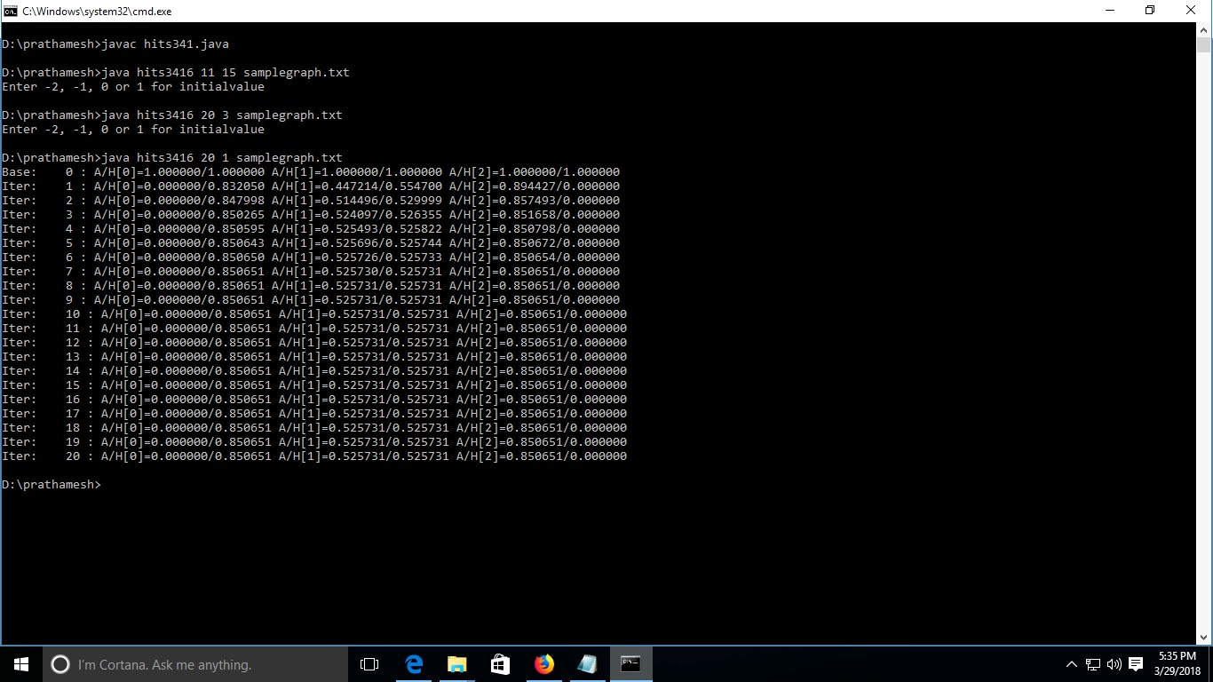

**References** :

1. Christopher D. Manning, Prabhakar Raghavan & Hinrich Schütze (2008). [*"Introduction to Information Retrieval"*](http://nlp.stanford.edu/IR-book/html/htmledition/hubs-and-authorities-1.html). Cambridge University Press*. Retrieved 2008-11-09*.
2. [**Jump up^**](https://en.wikipedia.org/wiki/HITS_algorithm#cite_ref-2) Kleinberg, Jon (December 1999). [*"Hubs, Authorities, and Communities"*](http://www.cs.brown.edu/memex/ACM_HypertextTestbed/papers/10.html). Cornell University*. Retrieved 2008-11-09*.